***Part 1b: Goal Outcomes (30%)***

**Summary of Shopify conversion goals**

Shopify tracks and provides additional conversion goals. According to Shopify,13.08% of visitors added item(s) to cart, 8.42% of visitors reached checkout and 6.47% of visitors purchased a product from the website. *(Churning at cart, limited delivery options, and delivery date can’t find)* Facebook accounted for 19% of all the traffic *Facebook Campaign suggestion*.

**Summary of best/worst conversion rates**

The “Home Page > 1min” goal has the highest conversion of all the goals we set up in Google Analytics (306 conversions), while “Complete Subscription Button” has the lowest (2 conversions).

The “Home Page> 1min” goal result was not too surprising given the amount of information about the business concept and products that is presented on the homepage. Visitors, especially new visitors, are likely to spend more than 60 seconds on the homepage reading the available information. (*double sided sword)* Moving forward, if we decide to change the layout of the homepage to include more concise information about the products, it would be important to monitor the conversion rate of this goal and compare it to the exit rate of the homepage.

On the other hand, the “Complete Subscription Button” goal has an extremely low conversion and might indicate that customers are not interested in this feature of the website. As such, EatNomz could think of strategies to either increase subscription or reconsider the need for such a service. It would also be interesting to see over time, if subscribers or return customers who do not subscribe for regular deliveries bring in greater revenue.

**Analysis of funnel results (Feb 29 - Mar 19)**

The only funnel that we have set up for the website that produces meaningful insight is the “Shopping Cart with Funnel” goal.

The goal has a conversion rate of 14.59%, and a funnel conversion rate for this goal is 17.30%. This means that 14.59% of all sessions on the website ended up at the shopping cart page at one point, while 17.30% funnel conversion rate is the number of sessions that completed the goal divided by the number of sessions that entered the funnel (104/(561+26+11) = 0.173).

The fact that these two conversion rates are relatively close shows that most visitors who reach the shopping cart page actually come through one or more pages defined in the funnel. This indicates that the website should continue to pay attention to the pages defined in the funnel as they will drive traffic to the shopping cart page. *(Paid search campaign insight)*

The highest dropout is between Home Page and “Buy Button” (collections/all page), 29.23% proceeded to “Buy Button”. Then, 48.19% proceeded from “Buy Button” to the “Xiang Gu Ji Tang” product page. Finally, 100% of visitors who funneled to the Xiang Gu Ji Tang page proceeded to the shopping cart page.

The 100% conversion for the final step of the funnel is actually inaccurate and can be caused by loopbacks or backfilling funnel steps. An analysis of the flow visualization could provide a more detailed description of the flow of traffic to the destination page (See next section).

The high dropout rate from home page to product page can be attributed to the high exit rate from the homepage (253 exits). This is the most problematic dropout from the funnel as it shows that the homepage was not able to continue to engage its visitors. This could be due to the design element issues of the website that was discussed in milestone 3. The homepage’s weakness in information design (too much information on the homepage) could in a high exit rate. The result of our proposed A/B test for the homepage might show a better version of the homepage that lowers the exit rate *(Where people go - find more infomrmation about the business, therefore, it is not really a cause for concern...).*

**Flow visualization analysis**

The flow visualization for the shopping cart page reveals several interesting insights.

Firstly, it explains the 100% conversion rate from the Xiang Gu Ji Tang page to the shopping cart page reflected in the funnel visualization. When exploring the traffic through the shopping cart page (Appendix F2), you can see that there are multiple sources of traffic to the shopping cart page. Appendix F2 also shows how loopbacks are counted into the funnel as well, thus contributing to the 100% conversion. A loopback can occur when a session skips a step in the funnel and end up in the destination page as well. Despite these technical nuances in Google Analytics, the fact that the goal conversion rate is close to the funnel conversion rate shows that the pages in the funnel contribute significantly to the goal, as mentioned above.

Another interesting insight that the funnel visualization provides is where traffic proceeds after it has reached the destination page. Of the 176 sessions that reached the shopping cart page, 57 went back to the “Buy Button” page (the “Buy” button), 37 went back to the home page, and 82 exited the funnel (this 82 included sessions that proceeded to checkout). Appendix F3 shows a breakdown of traffic that exited the funnel from the shopping cart page *(insight).* The 94 sessions that remained in the funnel after visiting the shopping cart page once again indicate the importance of the pages defined in the funnel.

More importantly, the 94 sessions that remain in the funnel also hint that many customers are not ready to checkout after they have added an item to cart. Therefore, the website should allow a “continue shopping” feature while showing a prominent update of shopping cart content, instead of directing users straight to the shopping cart page when they click on the “Add to Cart” button.

The flow visualization also reveals that of the 176 that ended up in the shopping cart page, 128 went through the “Buy Button” page. This shows the importance of the “Buy Button” page in driving traffic to the shopping cart page (do not direct to add to cart directly, instead of directing user straight to shopping cart page when clicking on “Add to Cart”, allow a “continue shopping feature” and show a prominent update of shopping cart content.).

Additionally, the flow visualization shows that 55 session circle back to the homepage from the “Buy Button” page. This is interesting and might indicate that users prefer to find out more information about the business or the company from the homepage instead of continuing to find out more about individual products.

Finally, the “Buy Button” page has the highest number of dropoffs (15.5% of total traffic) from the website as compared to other pages (except homepage) within the funnel. We could look into ways to lower the number of dropoffs from the funnel at this page *(insight - provide more information on this page such as overall reviews etc.)*.

**Appendix D**

D1: Shopify Goal summary

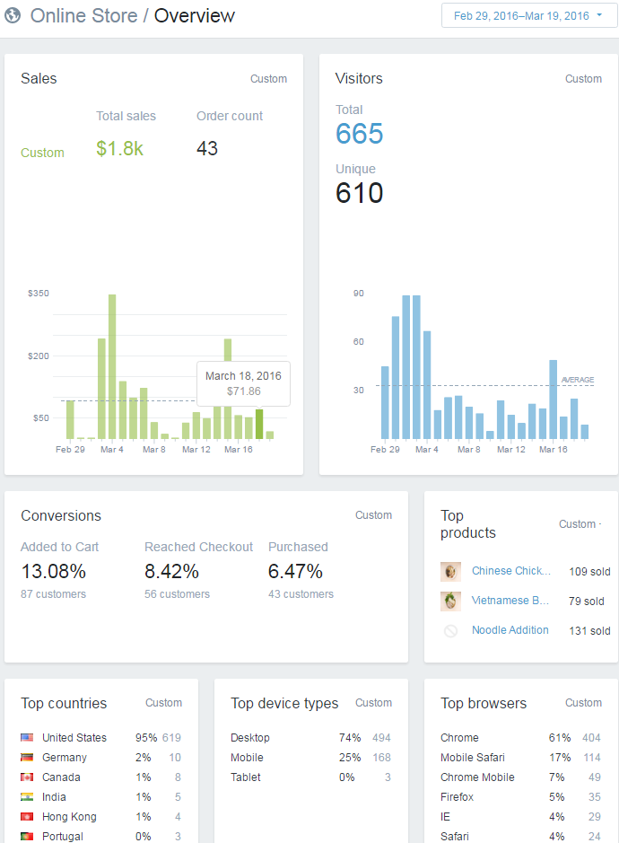

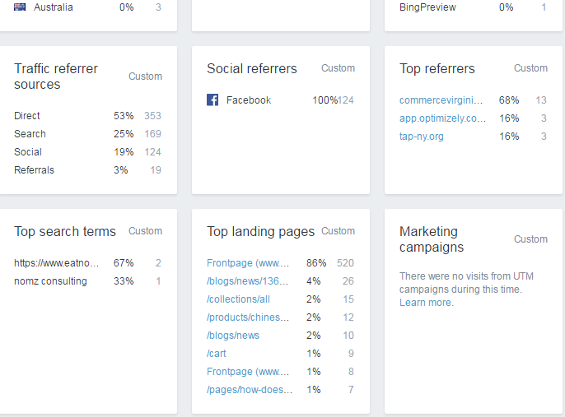

D2: Google Analytics Goal Summaries

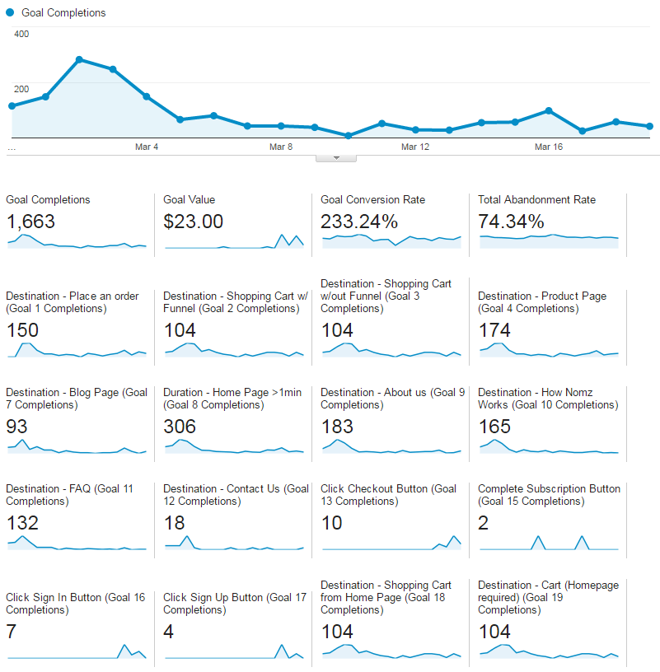

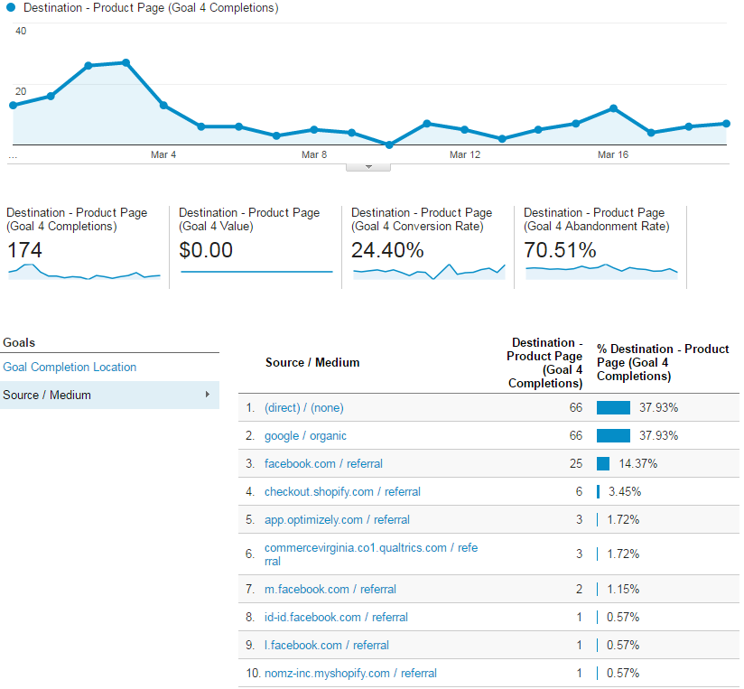

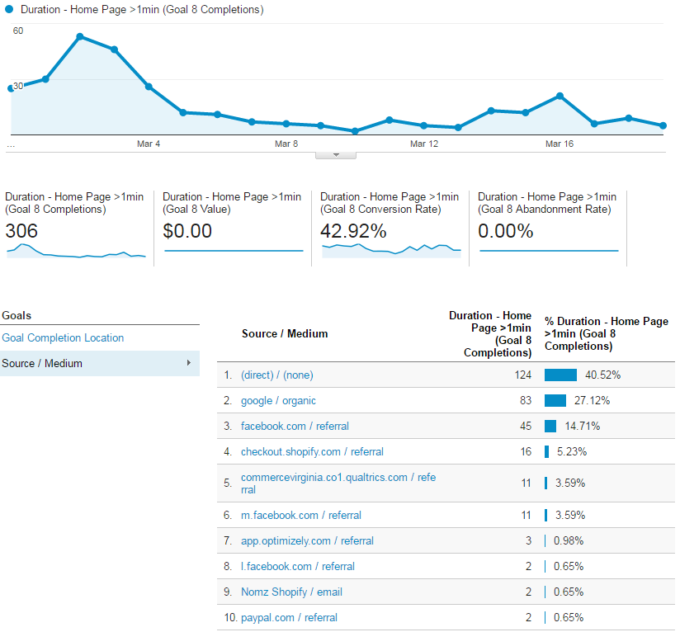

**Appendix E**

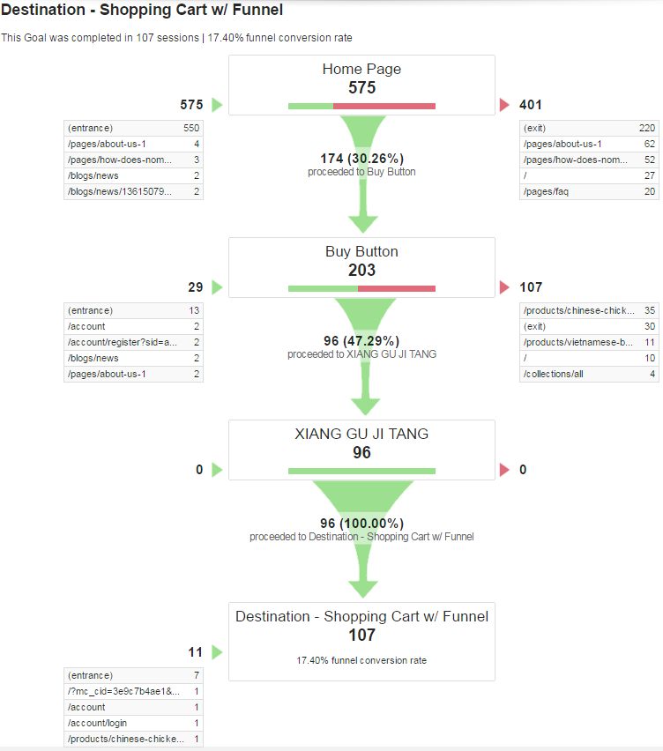

**Appendix F**

F1: Flow visualization - Shopping Cart with Funnel Goal

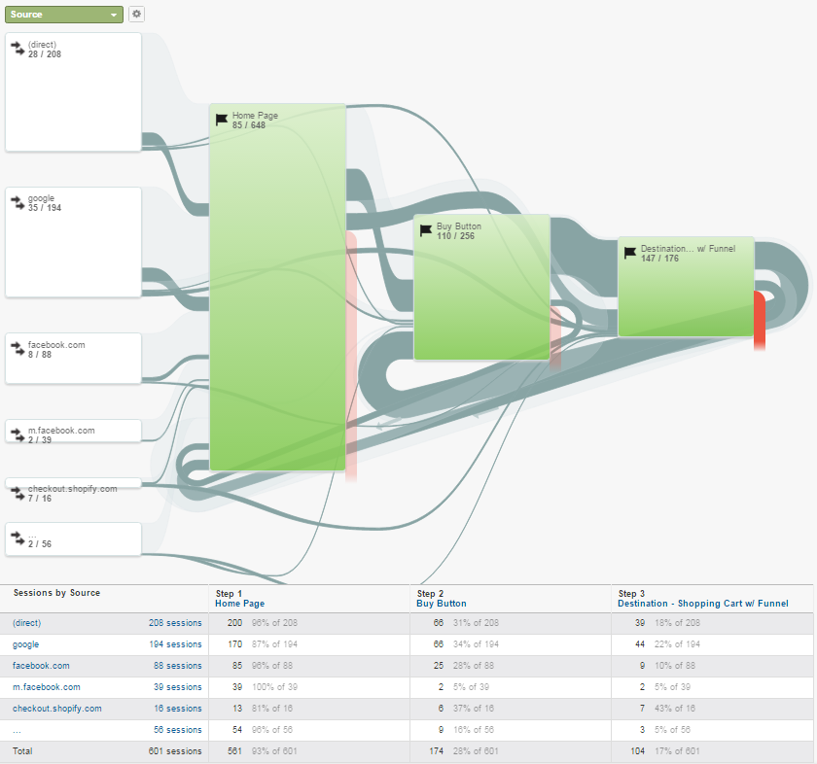

F2: Flow visualization - Shopping Cart with Funnel Goal (Exploring traffic to destination)

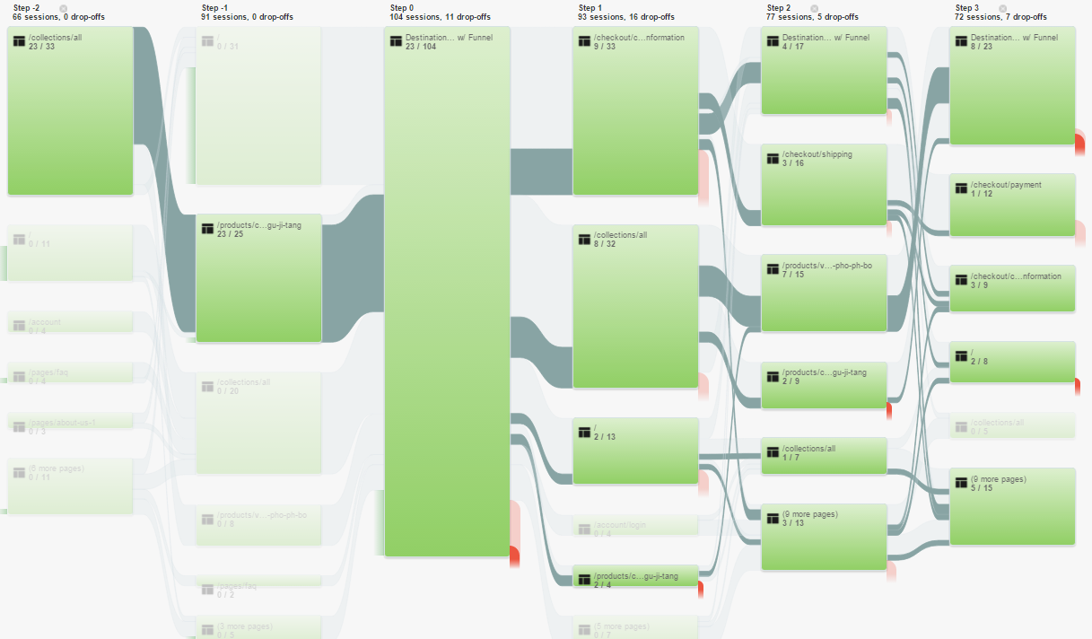

F3: Flow visualization - Shopping Cart with Funnel Goal (drop out from destination page)

